**Home Assignment Lab 10 for ECO R002**

2)

a. The following graphs compare the wage differences between treatment group and control group. Each diagram portrays that there is a mean difference in the wages between the two groups. However, it is hard to say that whether there is significant difference in the wages between the treatment and control groups.

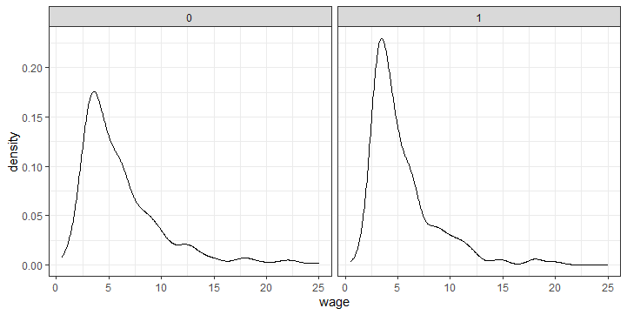

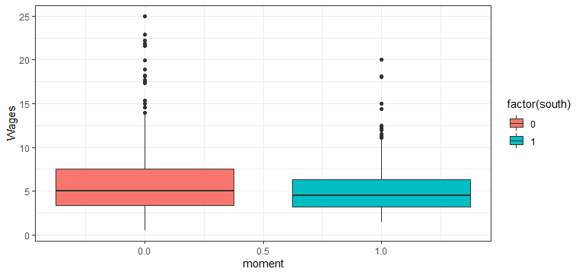

The t-test can be used to test the significant differences in the wages between both the groups. The t-test result given below revealed that there is a significant difference in the wages between treatment group and control group because the p-value of the t-statistics is less than 0.05.

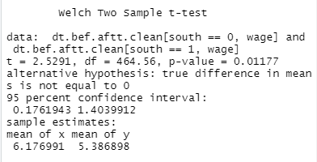

The difference in mean wage is 0.790093 (6.176991-5.386898).

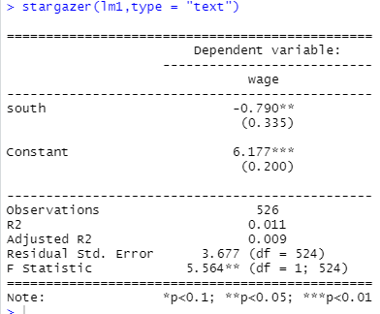

In this regression output, moment “south” lowered the wages by 0.79 pounds compared the absence of south moment.

b.Treatment effect when race and gender are controlled

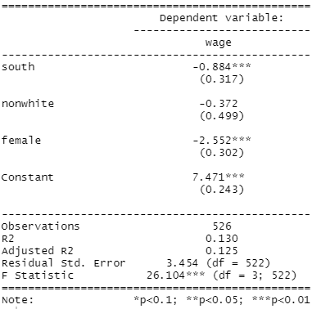

The moment “south” reduced significantly wage by 0.884 pounds, holding other variables are fixed.

c. To allow heterogeneity with treatment, the interaction term should be added with the above regression.

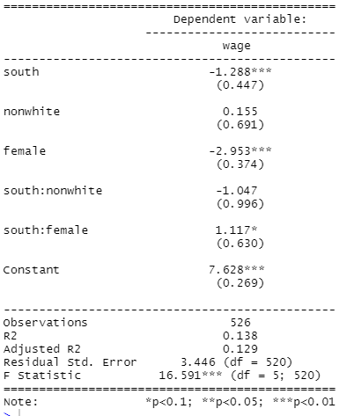

When we allow heterogeneity, the moment “south” deteriorate the wage more than absence of the heterogeneity.

c. (i) Now assume that there is a treatment implemented to race group (non-white)

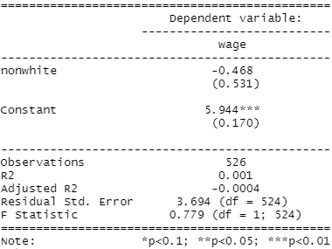

This output shows that non-white people get less wage compared to the control group, but it is not statistically significant.

d. The two-stage fitted regression can be applied to solve the problem of endogeneity. For this, we can apply an IV regression.

For example, consider the case: Wage=f(south, gender, race), where might be an endogeneity problem. For example, moment south might be associated with race. Therefore, “race” can be an instrument for variable “south”. In this, case, endogeneity might be reduced than earlier case.

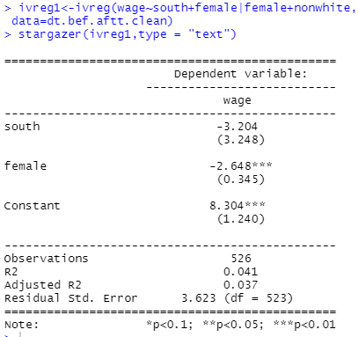

e)

i. it is possible to controlling experience in a regression model. However, we might face again endogeneity problem if “experience” is controlled.

e(ii) Yes, it is possible to account heterogenous treatment effects w.r.t experience

The estimated output is given below:

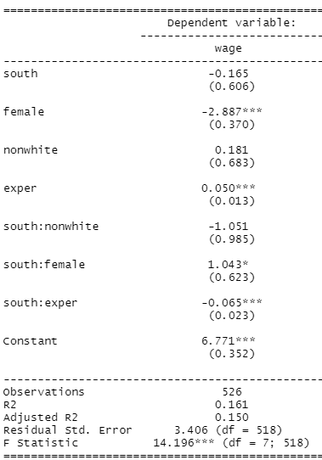

3)

a.

* Endogeneity: for example, moment “south” might be a part of variable “race”
* There might be same bias
* Insufficient number of samples

b.

* South is separate group
* There was statically significant mean difference between “south” and another group

c.

d. Summary statistics for wage

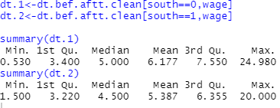

Summary statistics for each group

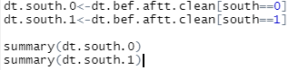

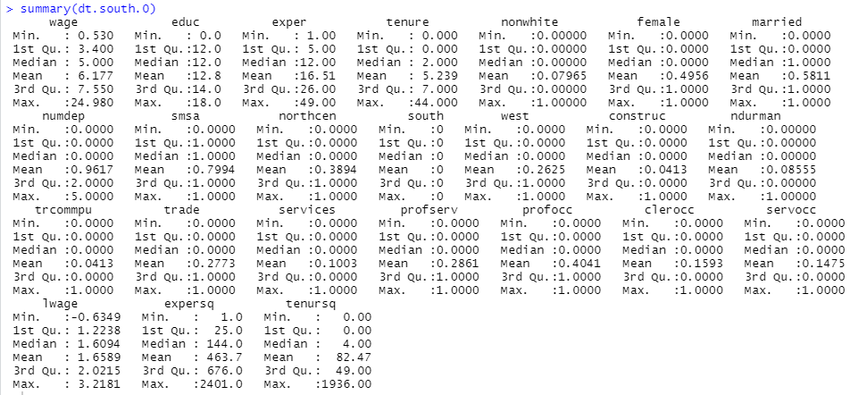

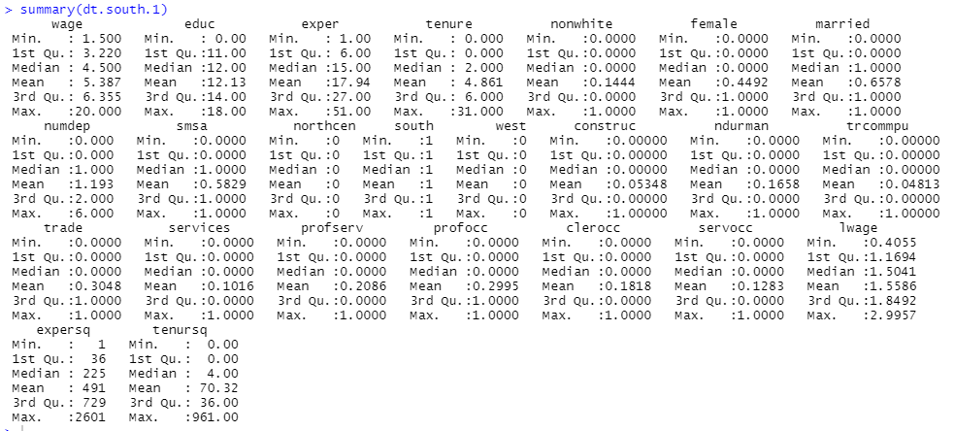

Equal Variance test

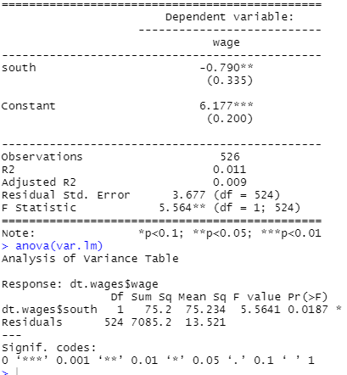

There is no evidence for equal variance

Two-sample test: because unbalanced sample for south=0, and south=1

